
CUSTOMER: ABB
1/2
DATA SHEET

GPN: EMVY630GRA221MKE0S (Invest. No.: G110260A0394D1)

DIMENSIONS (unit: mm)
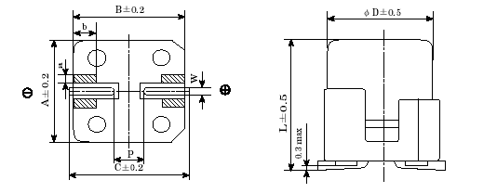
0.20max
Case code | φ D | L | A | B | C | W | P
KE0 | 12.5 | 13.5 | 13.0 | 13.0 | 13.7 | 1.0 to 1.3 | 4.2

Remark: Sn100% plating of lead wire

LIST OF STANDARDS

(1) Rated DC Working Voltage: 63V

(2) Nominal Capacitance: 220µF at 20°C and 120Hz

(3) Operating Temperature Range: -40°C to +105°C

(4) Capacitance Tolerance: -20% to +20% at 20°C and 120Hz

(5) Leakage Current: less than 138µA at 20°C, after 2 minute

(6) Dissipation Factor: less than 0.14 at 20°C and 120Hz

(7) Impedance: less than 0.19Ω at 20°C and 100kHz

(8) Ripple Current: max. 500mArms at 105°C, 100kHz

(9) | Low Temperature Characteristics: | Z(-25°C)/Z(20°C) = 2
 | (Max. impedance ratio at 120Hz to the 20°C value ) | Z(-40°C)/Z(20°C) = 3

(10) | Load Life: | The following specifications shall be satisfied when the capacitors are restored to 20°C after rated DC voltage is applied for 5,000 hours at 105°C.
- Capacitance change ≤ ±20% of the initial value
- Dissipation Factor ≤ 200% of the initial specified value
- DC Leakage current ≤ The initial specified value

(11) | Shelf Life: | The following specifications shall be satisfied when the capacitors are restored to 20°C after exposing them for 1,000 hours at 125°C without voltage applied.
- Capacitance change ≤ ±20% of the initial value
- Dissipation Factor ≤ 200% of the initial specified value
- DC Leakage current ≤ The initial specified value

2/2
DATA SHEET

GPN: EMVY630GRA221MKE0S (Invest. No.: G110260A0394D1)

(12) Recommended Reflow Profile (One reflow only)
Series / Size | Preheat | Pb-free type
Series / Size | Preheat | Time over  217°C | Time over  240°C | Peak temp.
MVY / 63V KE0 | 150-200°C  60 - 180 seconds | 50 seconds max. | 20 seconds max. | 245°C max.
Note: - Dissipation Factor ≤ 120% of the initial specified value after 1 x soldering
- ΔL ≤ 0.9mm after soldering

